**Marking Scheme:**

1. Explain the key components on which proofreaders must focus on? Clarify the term proof reading with any five symbols, instruction and example. (10+15)

Proof readers should concentrate on main regions such as:

i) Content – To effectively proof read a technical document, you should check the technical details against a reliable reference. You should also pay attention to the inconsistencies in data and look out for mistakes in labeling units of measures, Greek letters, formulas and mathematical symbols.

ii) Spelling – Misspellings are the most obvious errors to readers of published documents, so proofreaders should check carefully for accuracy of spelling. It is not wise to rely on spelling checkers in word processing programs, which will only flag words not in their own dictionary. Most spelling checkers do not recognize correct words used improperly, like ‘here’ and ‘hear’, ‘form’ and ‘from’, so proof readers should check each word for context as well as spelling.

iii) Others – Grammar errors should be checked. There should be consistency in the language used, whether it is American English or British English. Special care should be taken while checking the usage of Proper nouns. Any misspellings in names of products or people could lead to a lot of embarrassment. The accuracy of titles, headings and illustration captions should be checked very carefully.

Careful proof reading can ensure that a printed document is correct and attractive and that the document creates a good impression of the company that produced it.

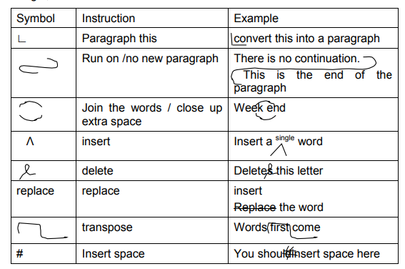

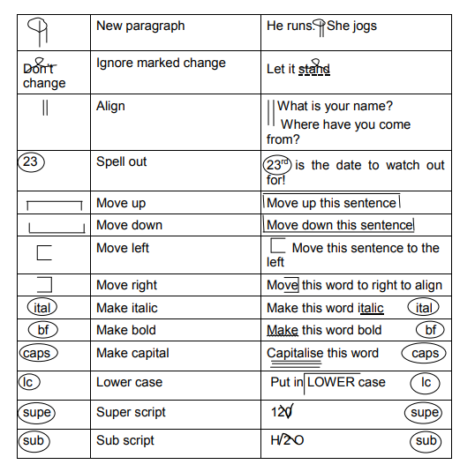

1. Mention any four descriptive differences between Macro Editing and Micro Editing. Justify the components of Project proposal. (16+9)
2. Macro revision, or just revision, refers to big-picture edits, such as making sure your plot makes sense, your characters are sympathetic, etc. Micro edits, also known as editing and copyediting, refer to line-edits, like spelling, grammar, punctuation, syntax, and word choice.
3. Rule of thumb: **Macro revision**deals with elements of storytelling (plot, character, inconsistencies, etc.), **Micro edits**deal with language and writing conventions (syntax, word choice, spelling, grammar, and punctuation.)
4. Macro editing is big-picture editing and includes: Making sure stories are worth running; Making sure stories have good leads, are organized and flow well; Making sure stories do not leave unanswered questions; Making sure stories are accurate; Making sure stories are objective; Making sure stories are legal, ethical, etc. whereas Micro-editing is the process of finding errors by inspection of individual observations. Editing procedure done at the record, or questionnaire level.
5. Micro-edits refer to smaller changes. Some examples of micro editing are: checking for spelling errors, cutting redundancies or deleting overused phrases. Macro-editing (also known as output editing or selection at the macro level) is a general approach to identify the records in a data set that contain potentially influential errors. It can be used when all the data, or at least a substantial part thereof, have been collected.

The following are the components of a proposal:

1. Problem
2. Vision
3. Benefits
4. Deliverables
5. Success Criteria
6. Deadline/Plan/Approach
7. Cost/budget
8. Describe the variations of Ethical Issues in Technical Communication. Jot down the points to remember while formulating a report. (17+8)

The following are the variation of ethical issues

1. Plagiarism versus credit for work done by others
2. Harassment and undermining of a person’s position
3. Stupid vs. malicious actions
4. Using discriminatory language
5. Using sentence structure to convey subtleties of meaning
6. Using logical fallacies

The major points to remember while writing the report are as follows:

1. Written in past tense
2. Don't use first person
3. Use indirect speech
4. use passive voice
5. Interpret the given diagram of Project Management Tree Swing Scenario: (25 marks)

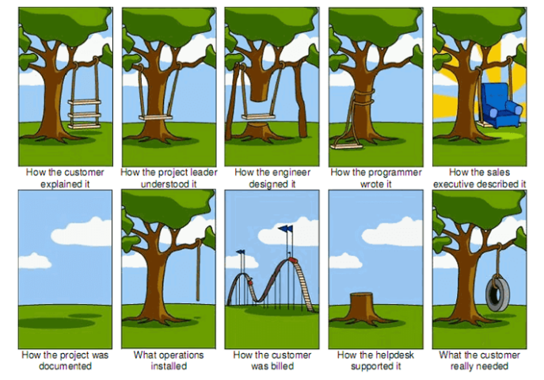

The [tree swing analogy](https://www.smart-jokes.org/how-it-projects-really-work.html) depicts how the customer explained the tree swing they wanted and how each department interpreted and implemented the requirements during product development.  
  
The [variation of the cartoon](https://www.businessballs.com/amusement-stress-relief/tree-swing-cartoons-new-versions/) showed up in 2003 and displays the perception gaps in software development projects. It then became popular in business circles, especially in management when projects did not go the way they expected due to issues.  
  
Oftentimes, pitfalls in communication, especially not listening to what the customer wanted for their “swing” are blamed for project failure. The project management tree swing analogy also reveals problems in product development and reminds everyone involved what and what not to do to complete a project.

Here’s how things happen during software project development:

1. Client request  
First, the customer describes what they want. When a customer describes what they want, it’s often an overstatement of what they need.  
  
2. Requirements gathering  
Requirements are gathered by the product owner and are summarized to how the customer explained them.   
  
3. Analysis of requirements  
Project managers and business analysts will translate the requirements to manageable tasks to kick off the project development.   
  
4. Code execution   
Software engineers follow PO’s summary requirements and make it work to some extent.  
  
5. Testing and QA  
Tested product will not work as expected because of several reasons. Oftentimes, miscommunication in requirements results in differences between expectations and output.

6. Sales

The product, even though it’s not workable, will be sold as working and bug-free software. The sales team can start their job by exaggerating its features.

7. Documentation  
Customers interested in the product will look for the documentation but to no avail.

8. Customer experience  
At last, what the customer wanted was a swing. Instead, they get a rope that’s nowhere near what they expected.

9. Billing  
Customers are billed for the experience and not for the functionality of the product.

10. Support  
When customers encounter a problem with their substandard product, they call the support team for help. However, the support team will only provide simple and ‘radical’ answers that can’t directly solve the issue.

11. Advertising

The marketing promotion team can over-advertise what the product can do to get a good deal.

12. Reality  
In retrospect, what the customer truly wanted was a simple tire swing. It's obviously what they imagined was more than what they needed.